Created on-02/08/2022

Flight Fare Prediction

Wireframe Documentation

Home Page

We have created the home page for Flight fare prediction project using html page which looks as follows:

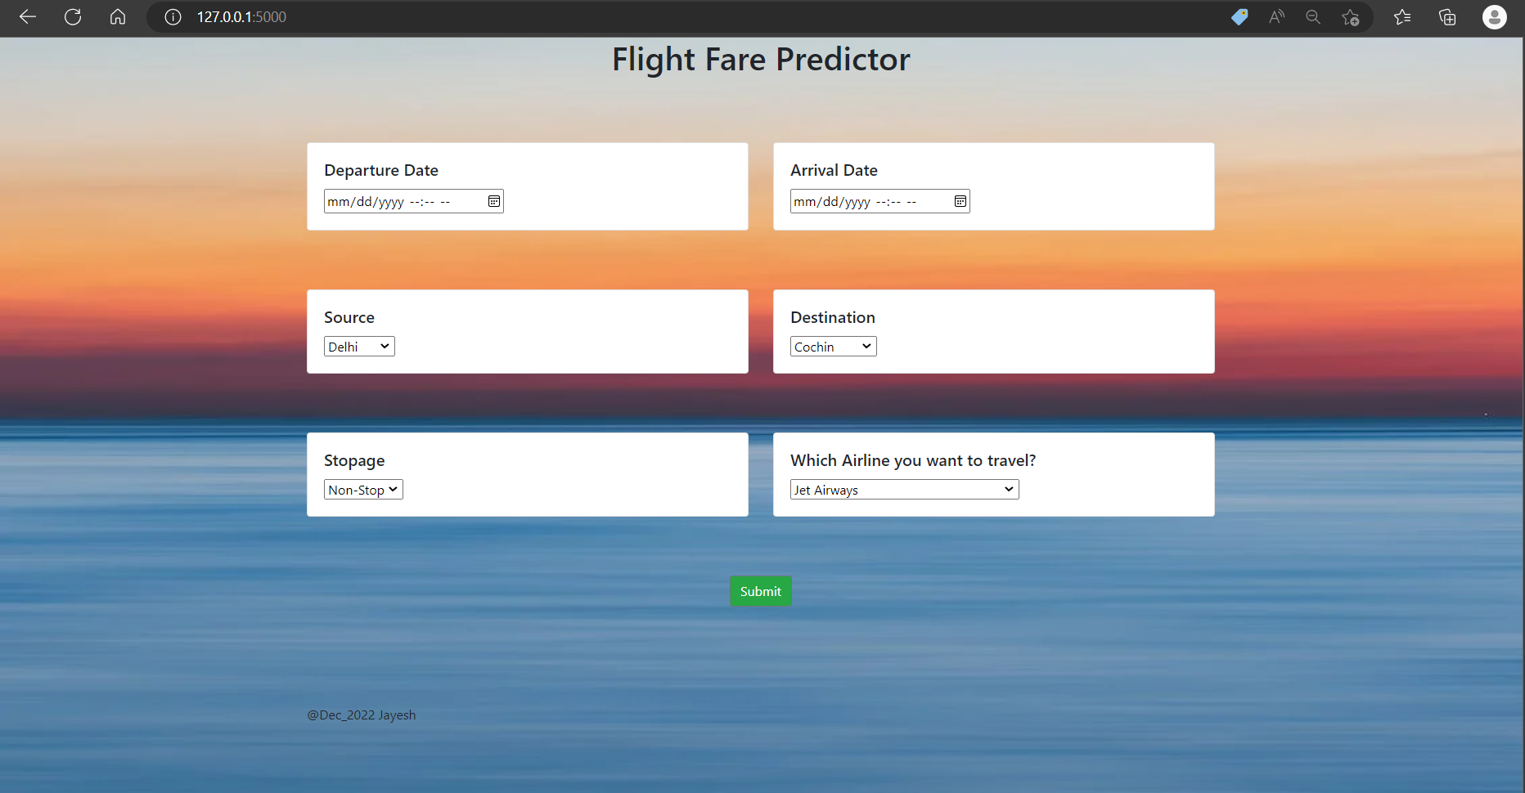

1. Departure Date: User must add the departure date and the time at which he/she will be travelling.
2. Arrival Date: User must add the arrival time and date at which he/she is supposed to arrival at the desired location.
3. Source: User must enter the source station of the journey that he is supposed to do.
4. Destination: User must enter the destination of his journey that is where he is supposed to end his journey.
5. Stoppage: User must enter the number of stoppages that his flight will be taking halts at.
6. Airline Name: User must enter the airline company name that he will be travelling with.

Prediction Page

After adding above details if user clicks on the submit button than predicted price of the flight will be printed on the page.

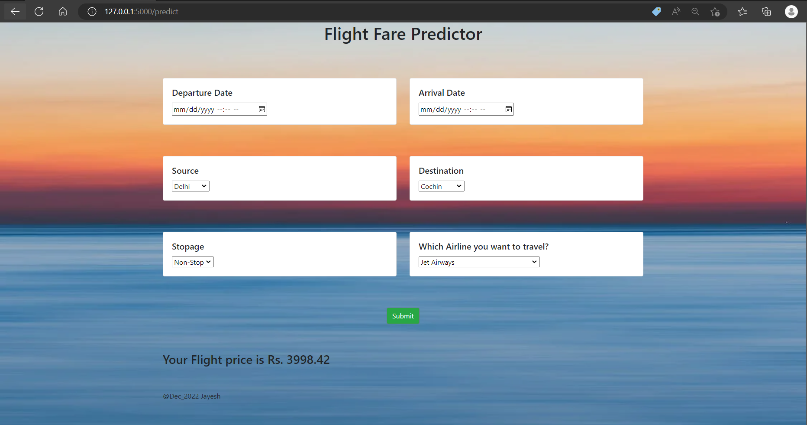

We can see that predicted price of the flight is printed on the page.